

Jami Account Management Server



Copyright
This document is Copyright © 2018-2025 by Savoir-faire Linux Inc. You may distribute it and/or modify it under the terms of either the GNU General Public License (https://www.gnu.org/licenses/gpl.html), version 3 or later, or the Creative Commons Attribution License (https://creativecommons.org/licenses/by/4.0/), version 4.0 or later.
All trademarks within this guide belong to their legitimate owners.

Community and support
Learn more about:
- Jami: https://jami.net/
- Jami extensions: https://jami.net/extensions/
- JAMS (Jami Account Management Server): https://jami.biz/
- Jami documentation: https://docs.jami.net/
Follow us for more:
- Mastodon: @Jami@mstdn.io
- Videos: https://docs.jami.net/videos/
We’d love to hear from you! Join the Jami community:
- Contribute: https://jami.net/contribute/
- Forum: https://forum.jami.net/
- GNU Mailman: jami@gnu.org
- Libera.Chat: #jami
- Matrix: #jami:matrix.org (bridged with Libera.Chat)
- Caution
Everything you send to a mailing list, including your email address and any other personal information that is written in the message, is publicly archived and is unable to be deleted.

Table of Contents
Copyright 2
Community and support 2
JAMS manual 4
Introduction 4
Obtaining JAMS 4
System requirements 4
JAMS concepts 5
Getting started 6
Step 1: Create an administrator account 7
Step 2: Set up the Certification Authority 8
Step 3: Set up the user database 9
Option 1: Lightweight Directory Access Protocol (LDAP) 9
Option 2: Microsoft Active Directory (AD) 10
Option 3: Local embedded database 11
Step 4: Set up the server parameters 12
Private DHT node 13
Admin guide 14
JAMS and Nginx 14
Troubleshooting and resetting 15
Running JAMS as a GNU/Linux Service 16
Running JAMS as a Windows Service 16
A. Download and install JAMS 16
B. Download and install Java Development Kit (JDK) 16
C. Download OpenSSL to generate a key and a certificate 16
D. Add OpenSSL to System Environment Variables 18
E. Configure OpenSSL 18
F. Expose the localhost to the Internet 19
G. Create a JAMS Windows Service (Embed Tomcat Server Windows Service) to start JAMS with the server 20
Client guide 21
Connect with desktop clients 22
Connect with Android clients 23
Connect with iOS clients 24
Connect with web clients 25

JAMS manual
The JAMS manual contains admin and user guides for the Jami Account Management Server. The Jami Account Management Server (JAMS) enables Jami to be easily deployed in any enterprise and allows users to connect using their centralized credentials and create local accounts. JAMS allows all enterprises to manage their own Jami community while taking advantage of Jami’s distributed network architecture.

Introduction
JAMS is a server application used to enroll Jami clients in an enterprise environment. Currently, JAMS supports 3 sources for user authentication:
- Lightweight Directory Access Protocol (LDAP),
- Active Directory (AD), and
- An embedded database.

Obtaining JAMS
The latest version of JAMS can be downloaded at https://jami.biz/. The source code is available at https://git.jami.net/savoirfairelinux/jami-jams.

System requirements
Requirement | Details
Processor | 1 gigahertz (GHz) or faster with 1 or more cores on a compatible 64-bit processor or System on a Chip (SoC).
RAM | 4 gigabytes (GB).
Storage | 1 gigabyte (GB) of available storage space.
Operating system | GNU/Linux, Apple macOS, or Microsoft Windows.
Java | Version 11 or higher.
Database | LDAP-compatible directory (such as OpenLDAP), Microsoft Active Directory (AD), or a local embedded database.

JAMS concepts
JAMS was built with security in mind; therefore, it is intimately related to the X.509 certificate management workflows.
The central concepts that are used in JAMS are:
- the Certification Authority (CA) and
- the Certificate Signing Request (CSR).
In the JAMS paradigm, a device (Jami client) requests a certificate from the server and then presents it to other devices to be recognized as a valid member of the organization. Therefore, JAMS must be provided with a certificate authority in order to work properly.
In order to be completely secure, JAMS does not generate certificates for devices. JAMS instead issues certificates based on a certificate signing request sent to it by the device. This therefore removes the requirement to send a private key over the wire.
The following diagram shows the entire process of how a device enrolls with JAMS:
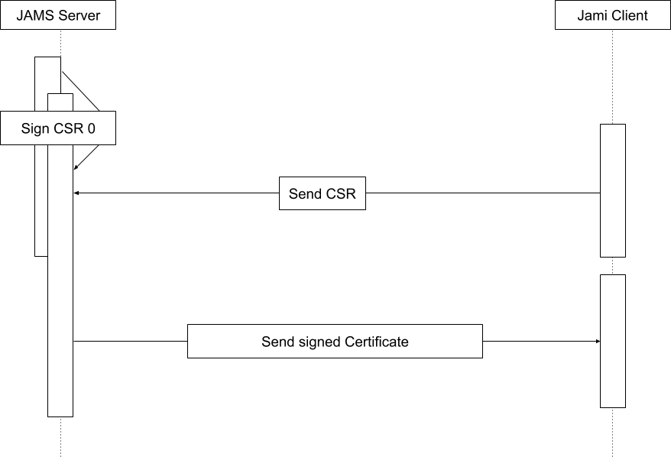

Getting started
- Download the latest version of JAMS from https://jami.biz/.
- Unpack the .tar file to any directory.
- It is mandatory to run JAMS using a secure SSL connection.
A domain name is required to request a key and a certificate. A domain name can be purchased if one is not available. Set the domain name to point to the server before proceeding to the next step.
A pair of key certificates can be purchased from any online provider. However, obtaining a free pair using Let’s Encrypt is recommended.
In order to generate a pair of key certificates, Certbot can be used following the instructions on the https://certbot.eff.org/ page.
Certbot will provide specific instructions when the web server software and operating system are entered.
Install Certbot using snap:
sudo snap install --classic certbot
Ensure that the Certbot command can be run:
sudo ln -s /snap/bin/certbot /usr/bin/certbot`
In order to get a certificate, execute:
sudo certbot certonly
and follow the instructions.
The certificate and key are generated in a specific folder; please see the output from Certbot to locate them.
It is required to copy them in the current folder where the jams-launcher.jar file is located.
- Current limitation
JAMS currently does not support reading encrypted private keys that require a password unlock.

- Navigate to the directory where the JAMS package has been extracted and execute the following command:
java -jar jams-launcher.jar PORT SSL_CERTIFICATE SSL_CERTIFICATE_KEY
Argument | Details
PORT | The TCP port on which JAMS is to listen for incoming connections.
SSL_CERTIFICATE | The location of the PEM-formatted SSL Certificate file.
SSL_CERTIFICATE_KEY | The location of the PEM-formatted key file, which is used with the SSL Certificate file from above.
An example of the command would be:
java -jar jams-launcher 443 server.pem server.key
- Note
Any port above 1024 can be safely used to run JAMS.

Step 1: Create an administrator account
The administrator account manages Jami users and groups.
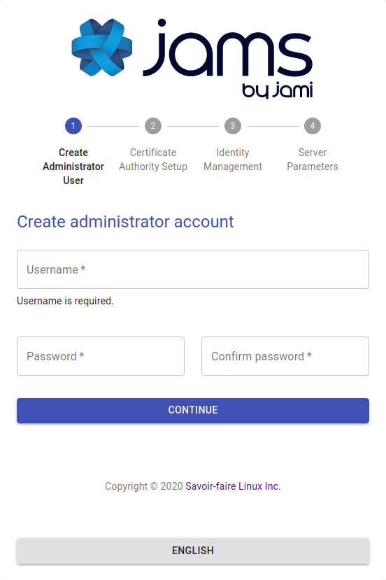

Step 2: Set up the Certification Authority
The second step is to define the certification authority.
- Important
A CA is not a server SSL certificate; it is a certificate that has the power to issue other certificates. Do not use the import option unless the enterprise’s security officer has issued the CA certificate. Most commercially available certificates (i.e., those issued by GoDaddy, Let’s Encrypt, etc.) are not CA certificates. It is highly recommended that end-users create and use a self-signed CA, as providing an incorrect certification type will lead to a non-functional server.
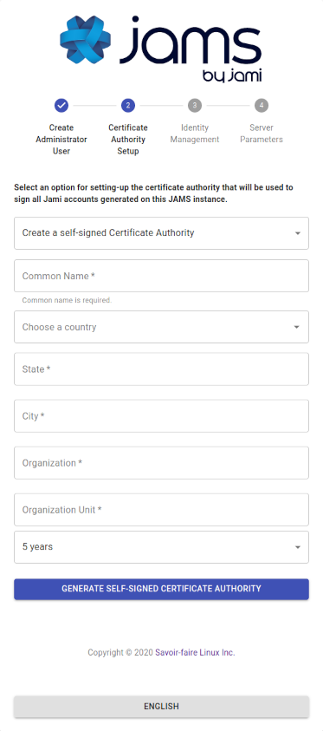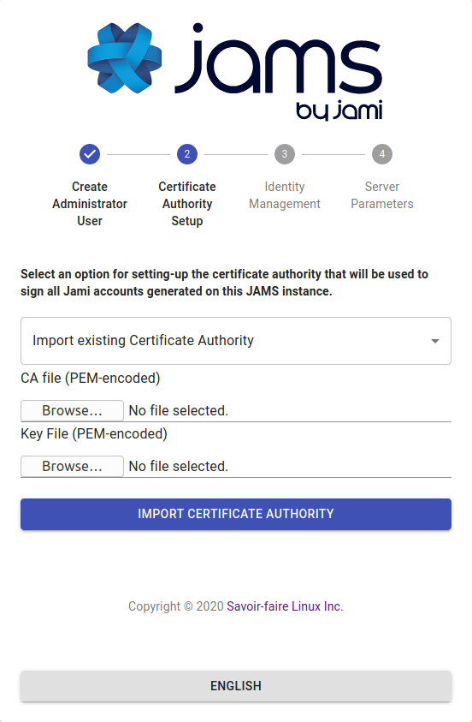
This certificate will be used to sign the enrollment requests that come from Jami devices. It is highly recommended that the following articles are read to become familiar with the X.509 certificate standard processes and practices:
- https://www.securew2.com/blog/public-key-infrastructure-explained/
- https://cheapsslsecurity.com/blog/understanding-the-role-of-certificate-authorities-in-pki/

Step 3: Set up the user database
JAMS supports 3 different sources for the authentication of users:
- LDAP-compatible directory (such as OpenLDAP)
- Microsoft Active Directory
- Local embedded database

Option 1: Lightweight Directory Access Protocol (LDAP)
If the enterprise provides an LDAP directory for user management, it is required to know its access information and an automated account that has read-only rights to do use look-ups.
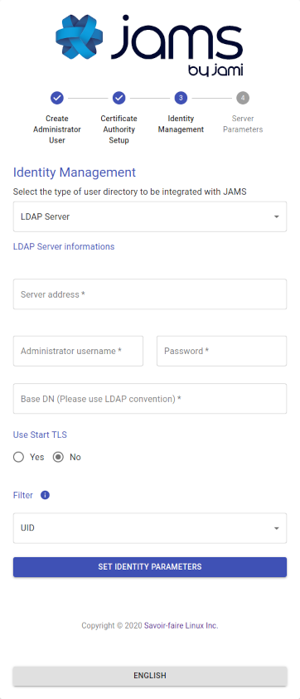
The admin should provide most of the required information; however, the following is a detailed overview of each field:
Field | Details
Use StartTLS | The LDAP server can be configured to use either TLS/STARTTLS or PLAIN sockets; if STARTTLS is used, mark the value as true.
Server Address | The address of the server with respect to the JAMS server, the LDAP is not required to be publicly accessible but should be accessible to JAMS. Either ldap:// or ldaps:// should precede the address.
Port | The port on which the LDAP server is listening for requests (usually 389 for PLAIN/STARTTLS and 636 for SSL/TLS).
Administrator Username | This is NOT the LDAP's administration account credentials but the credentials of the account that has read permissions to the LDAP database in order to look up users. The format is generally cn=bot,ou=robots,dc=domain,dc=org.
Password | The password used by the account above.
BaseDN | The base realm where the user accounts are located; in most cases, it is ou=users,dc=enterprise,dc=org.

Option 2: Microsoft Active Directory (AD)
If the enterprise provides Active Directory (AD) for user management, it is required to know its access information and an automated account that has read-only rights to do use look-ups.
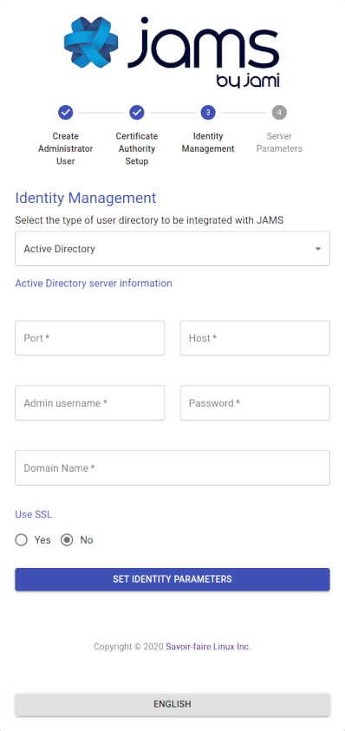
The admin should provide most of the required information; however, the following is a detailed overview of each field:
Field | Details
Port | The port on which Active Directory (AD) is listening (generally it is either 389 or 636).
Host | The address of the server with respect to the JAMS server, the Active Directory (AD). It not required to be publicly accessible but should be accessible to JAMS.
Administrator Username | This is NOT the Active Directory's administration account credentials but the credentials of the account that has read permissions to the Active Directory database in order to look up users. The format is generally cn=bot,ou=robots,dc=domain,dc=net.
Password | The password used by the account above.
Use SSL | Whether the server uses SSL for data transmission.
Domain Name | This is the legacy-formatted Windows Domain Name (i.e., WINDOMAIN).

Option 3: Local embedded database
The local database does not require any additional configuration; everything in the process is automated. This option allows for the creation of Jami users on the fly directly from the JAMS interface.
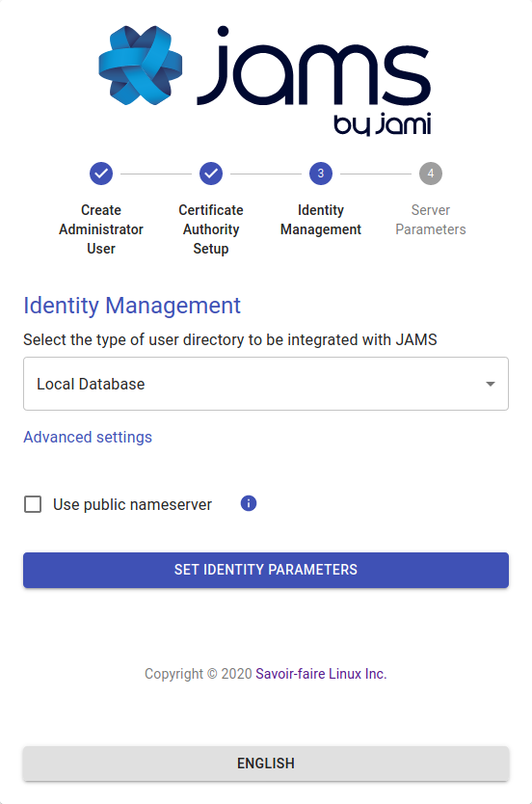
- Advanced settings
By default, the “Use public name server” option is disabled. Jami usernames of JAMS users will not be stored on the public Jami name server. Users can communicate with users outside the organization by using their 40-character fingerprint. Enable this option to allow JAMS users in the organization to also search for external users on the public name server.

Step 4: Set up the server parameters
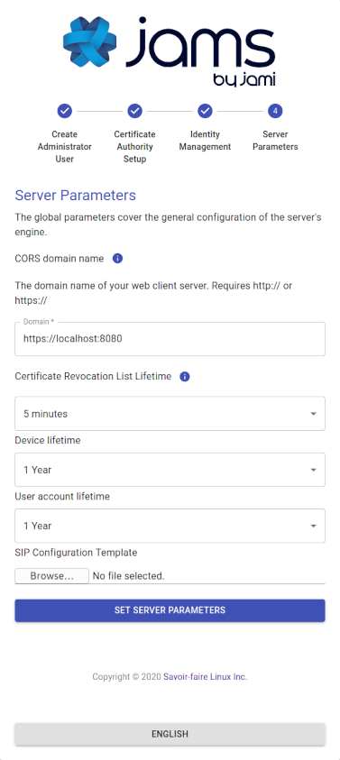
Parameter | Details
CORS Domain Name | The domain on which the JAMS client and administration UI will be running.
Certificate Revocation List Lifetime | The frequency at which the CRL is updated in memory.
Device Lifetime | How long a device's certificate is valid before being considered stale and requiring re-enrollment.
User Account Lifetime | How long a user account is valid before being considered stale and requiring re-enrollment.
- Important
The CORS Domain Name corresponds to the web address used to access the Web UI. By default, it is set to the same URL address as the one where JAMS is deployed. Only set a different URL address if the Web UI has a different URL address from the one where JAMS is deployed.
Select the Set Server Parameters button to finalize the configuration and be redirected to the JAMS interface.


If JAMS has been configured with an LDAP database or Active Directory (AD), the list of users in the organization should be visible in JAMS. If JAMS has been configured with a local embedded database, new users can be created by selecting the Create User button.

Private DHT node
1. The JAMS server does not provide an OpenDHT bootstrap node. OpenDHT is required to be installed to provide bootstrap functionality.
2. If the network no longer has Internet access, clients should be able to communicate with this single DHT node, but it can take some time (10-15 minutes) to update the table.
3. The DHT is only used to allow nodes to find each other: data is sent P2P or through a TURN server. If required, the TURN server is installed separately.

Admin guide
By default, the JAMS (Jami Account Management Server) runs an embedded Apache Tomcat server visible on port 8080. However, this is impractical for many reasons. This guide is designed to help with setting up a JAMS to run in a production environment.

JAMS and Nginx
It is generally not recommended to expose JAMS directly to the outside world. JAMS is required to run in SSL mode. It is recommended to place JAMS behind an Nginx or similar web server. The Nginx, or similar, web server would proxy requests between the outside world and JAMS.
The following is an example map of how the JAMS could be configured behind an Nginx server. The process would be similar if any other type of proxy solution is used.
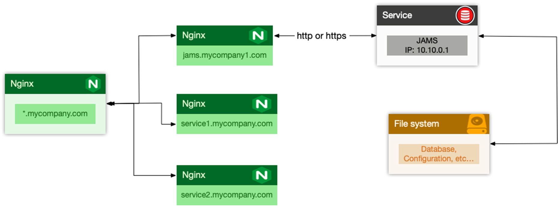
The IP 10.10.0.1 is random and should be seen as an example.

Typically a new site called jams-site.conf would be added to the Nginx configuration. It would contain the following entries if an SSL certificate was placed at the Nginx level:
server {
listen 443 ssl;
listen [::]:443 ssl;
ssl on;
ssl_certificate /etc/certificates/mycertificate.pem
ssl_certificate_key /etc/certificates/mycertificatekey.pem
ssl_client_certificate /jams/installation/path/CA.pem;
ssl_verify_client optional;
ssl_verify_depth 2;
client_max_body_size 100M;
server_name jams.mycompany.com;
location / {
# Block client-supplied headers that could be used to spoof
if ($http_x_client_cert) {
return 400;
}
proxy_pass http://10.10.0.1:8080/;
proxy_set_header X-Real-IP $remote_addr;
proxy_set_header Host $http_host;
proxy_set_header X-Client-Cert $ssl_client_escaped_cert;
}
}
This is the preferred setup method by most admins, as local traffic is usually run unencrypted since it is usually either an inter-VM connection, a VLAN, or another dedicated link.
- Tip
Since the CA is generated during the JAMS initial configuration, Nginx needs to be restarted once the initial setup is completed.

Troubleshooting and resetting
If a restart from 0 (i.e., reset everything and drop existing data) is required, delete the following files in the distribution folder (<project-root-folder>/jams):
The internal JAMS folder: <project-root-folder>/jams/jams
derby.log
oauth.key
oauth.pub
config.json
This will reset the server to its original state, and the configuration wizard is able to be run again. Before performing this operation, please ensure that the server is shut down.

Running JAMS as a GNU/Linux Service
Running JAMS as a GNU/Linux Service is fairly straightforward with systemd—simply create a service unit file with the following structure:
[Unit]
Description=JAMS Server

[Service]
Type=simple
WorkingDirectory=[DIRECTORY WHERE JAMS WAS UNZIPPED]
ExecStart=/usr/bin/java -jar [DIRECTORY WHERE JAMS WAS UNZIPPED]/jams-launcher.jar PORT SSL_CERTIFICATE SSL_CERTIFICATE_KEY

[Install]
WantedBy=multi-user.target
The parameters PORT, SSL_CERTIFICATE and SSL_CERTIFICATE_KEY are optional (however, PORT can be used alone, whereas the SSL_CERTIFICATE comes in a pair with SSL_CERTIFICATE_KEY).

Running JAMS as a Windows Service

A. Download and install JAMS
- Visit https://jami.biz/ and download JAMS.
- Extract JAMS to C:\jams

B. Download and install Java Development Kit (JDK)
- Download JDK 11 from https://www.oracle.com/java/technologies/javase-jdk11-downloads.html (choose the corresponding VM architecture).
- Install it using the installation wizard.

C. Download OpenSSL to generate a key and a certificate
- Download the OpenSSL Binary Distributions for Microsoft Windows from https://kb.firedaemon.com/support/solutions/articles/4000121705. Alternatively, select another OpenSSL binary.
- Once downloaded, extract it to C:\openssl.
- Create a bin folder inside, i.e., C:\openssl\bin.
- Create a new file inside the bin folder named openssl.cnf (make sure that the file extension is .cnd and not .cnd.txt).
- Copy and paste the following default configuration from http://www.flatmtn.com/article/setting-openssl-create-certificates.html:

#
# OpenSSL configuration file.
#

# Establish working directory.

dir = .

[ca]
default_ca = CA_default

[CA_default]
serial = $dir/serial
database = $dir/certindex.txt
new_certs_dir = $dir/certs
certificate = $dir/cacert.pem
private_key = $dir/private/cakey.pem
default_days = 365
default_md = md5
preserve = no
email_in_dn = no
nameopt = default_ca
certopt = default_ca
policy = policy_match

[policy_match]
countryName = match
stateOrProvinceName = match
organizationName = match
organizationalUnitName = optional
commonName = supplied
emailAddress = optional

[req]
default_bits = 1024 # Size of keys
default_keyfile = key.pem # Name of generated keys
default_md = md5 # Message digest algorithm
string_mask = nombstr # Permitted characters
distinguished_name = req_distinguished_name
req_extensions = v3_req

[req_distinguished_name]
# Variable name Prompt string
#-------------------------- ---------------------------------------
0.organizationName = Organization Name (company)
organizationalUnitName = Organizational Unit Name
(department, division)
emailAddress = Email Address
emailAddress_max = 40
localityName = Locality Name (city, district)
stateOrProvinceName = State or Province Name (full name)
countryName = Country Name (2 letter code)
countryName_min = 2
countryName_max = 2
commonName = Common Name (hostname, IP, or username)
commonName_max = 64

# Default values for the above, for consistency and less typing.
# Variable name Value
#-------------------------- ---------------------------------------
0.organizationName_default = My Company
localityName_default = My Town
stateOrProvinceName_default = State or Province
countryName_default = US

[v3_ca]
basicConstraints = CA:TRUE
subjectKeyIdentifier = hash
authorityKeyIdentifier = keyid:always,issuer:always

[v3_req]
basicConstraints = CA:FALSE
subjectKeyIdentifier = hash

D. Add OpenSSL to System Environment Variables
Go to Edit the system environment variables → Environment Variables. In System variables, edit Path and add C:\openssl\.

E. Configure OpenSSL
- Open the Command Prompt.
- Execute the following command to set the path to the OpenSSL configuration file.
set OPENSSL_CONF=C:\openssl\bin\openssl.cnf
- Type cd C:\jams
- To generate the Key and Certificate, type:
openssl req -newkey rsa:2048 -new -nodes -x509 -days 3650 -keyout server.key -out server.pem
- Follow the wizard.
- Once the key and certificate are generated, type dir. The output should look like:
C:\jams>dir
Volume in drive C has no label.
Volume Serial Number is BC94-9EF2

Directory of C:\jams

2020-11-10 12:38 PM <DIR> .
2020-11-10 12:38 PM <DIR> ..
2020-10-22 10:56 AM 5,186,016 jams-launcher.jar
2020-10-22 10:56 AM 33,413,882 jams-server.jar
2020-11-10 11:53 AM <DIR> libs
2020-11-10 12:34 PM 1,732 server.key
2020-11-10 12:38 PM 1,336 server.pem
2020-10-22 04:05 PM 2,047,932 userguide.pdf
5 File(s) 40,650,898 bytes
3 Dir(s) 93,365,936,128 bytes free
- Execute the following command to start JAMS:
java -jar jams-launcher.jar PORT_NUMBER (eg. 8443 or 443) server.pem server.key
- Open a navigator on the server and visit https://localhost:443 or https://localhost:8443 to validate that JAMS is working.
- Type CTRL+C to close the application.

F. Expose the localhost to the Internet
- Press the Windows key or click the Windows icon and search for Windows Defender Firewall with Advanced Security.
- Right-click Inbound Rules and click New Rule…
- Select Port, click Next.
- Specify the port to use, for example, 443 or 8443, and click Next.
- Select Allow the connection and click Next.
- Leave Domain Private and Public unchanged, and click Next.
- Name the rule JAMS Inbound and click Finish.
- Right-click on Outbound Rules and click New Rule…
- Select Port, click Next.
- Specify the port to use, for example, 443 or 8443, and click Next.
- Select Allow the connection and click Next.
- Leave Domain Private and Public unchanged, and click Next.
- Name the rule JAMS Outbound and click Finish.
- The localhost is now available on the Internet. The application can now be visited through the server domain name or IP address on port 443 or 8443.

G. Create a JAMS Windows Service (Embed Tomcat Server Windows Service) to start JAMS with the server
- In order to create a JAMS Windows Service, the NSSM (the Non-Sucking Service Manager) can be used. NSSM is available at http://nssm.cc/download and https://github.com/kirillkovalenko/nssm.
- Once NSSM has successfully downloaded, open a Command Prompt and change the directory to:
nssm-2.24\win64
- To install and open a graphical user interface (GUI), type:
nssm.exe install JAMS
- In the Path field, specify the path to the Java executable, for example:
"C:\Program Files\Common Files\Oracle\Java\javapath\java.exe"
- In the Startup directory, for the installation folder path, type:
"C:\jams"
- In the last field, add the following arguments:
-classpath "C:\jams" -jar jams-launcher.jar PORT_NUMBER server.pem server.key
where PORT_NUMBER is the port number to use to serve the application, for example, 443 or 8443.
- Now the JAMS application will start with the server.
Source: https://medium.com/@lk.snatch/jar-file-as-windows-service-bonus-jar-to-exe-1b7b179053e4

Client guide
This tutorial has instructions on how to connect to JAMS (Jami Account Management Server) with Jami desktop (GNU/Linux, macOS, and Windows), Jami mobile (Android and iOS), and Jami web clients.
For the purposes of this tutorial, it is assumed that:
- The server and the device attempting to connect are either:
  - On the same network, or
  - The server is publicly accessible to the outside world.
- A valid username/password pair to connect to the server is entered.

Connect with desktop clients
Jami desktop clients are available for devices with 64-bit versions of GNU/Linux, macOS, and Windows operating systems.
In Jami, open the Add another account page. Select Advanced features.
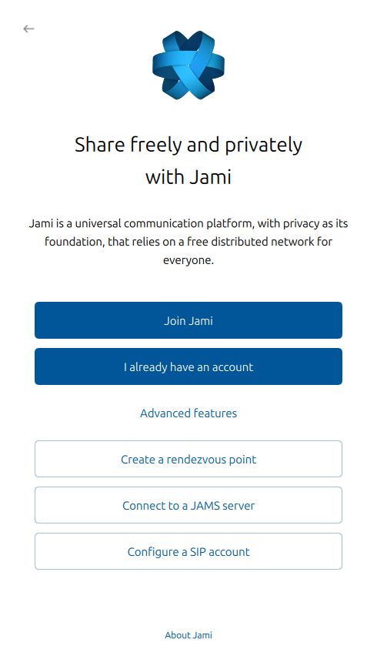
Select Connect to a JAMS server.
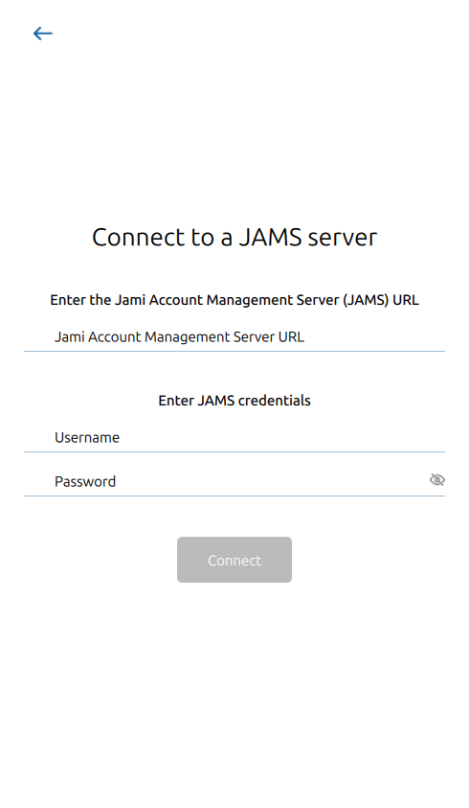
The JAMS URL is the DNS address of the server. The Username and Password correspond to the account. If a server has been configured with an LDAP/AD backend, the Username and Password would be the LDAP/AD username and password.

Connect with Android clients
Jami mobile clients are available for devices for smartphones, tablets, and TVs running the Android operating system.
In Jami, open the Add another account page.
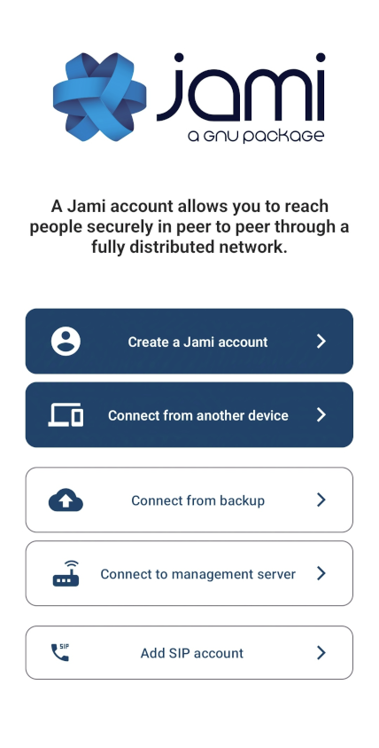
Select Connect to management server.
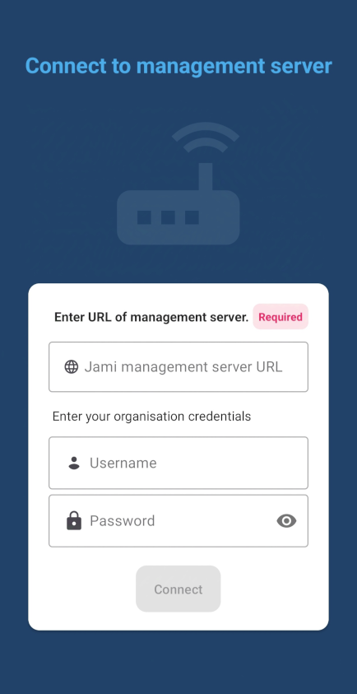
The JAMS URL is the DNS address of the server. The Username and Password correspond to the account. If a server has been configured with an LDAP/AD backend, the Username and Password would be the LDAP/AD username and password.

Connect with iOS clients
Jami mobile clients are available for devices for iPhones and iPads running the iOS operating system.
In Jami, open the Add another account page.
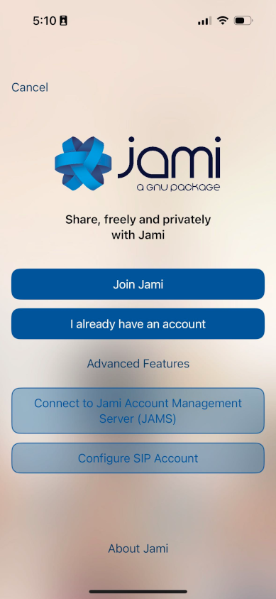
Select Connect to JAMS (Jami Account Management Server).
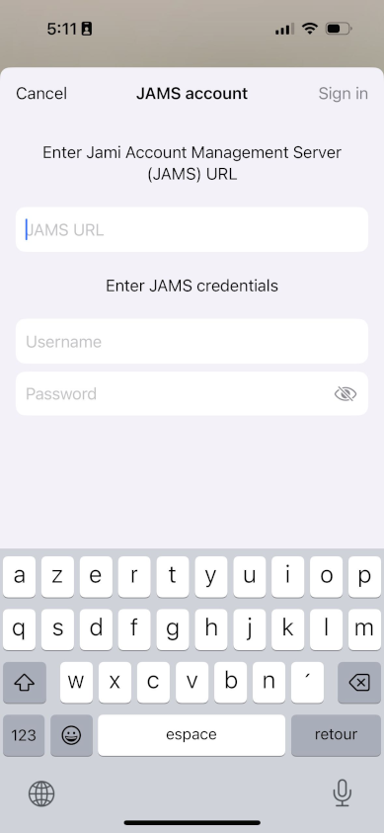
The JAMS URL is the DNS address of the server. The Username and Password correspond to the account. If a server has been configured with an LDAP/AD backend, the Username and Password would be the LDAP/AD username and password.

Connect with web clients
Jami web clients run on modern web browsers.
In a web browser address bar (also location bar or URL bar), enter the JAMS URL address.
If the JAMS administrator has disabled Jami authentication, enter the Username and Password.
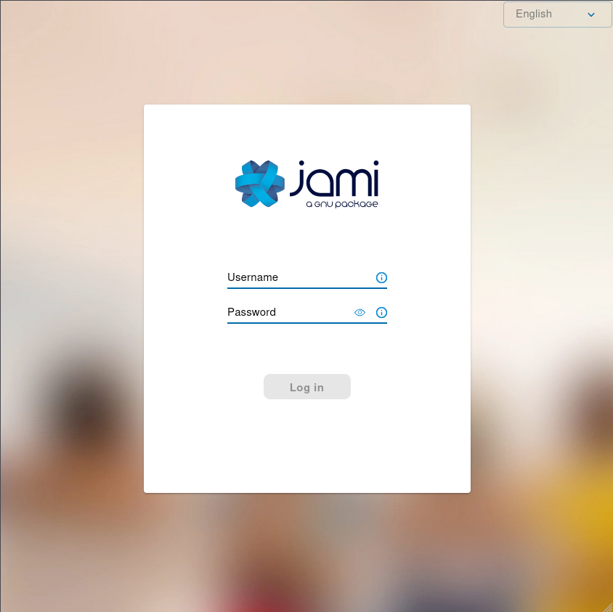
If the JAMS administrator has enabled Jami authentication, the Jami or JAMS authentication method is required.
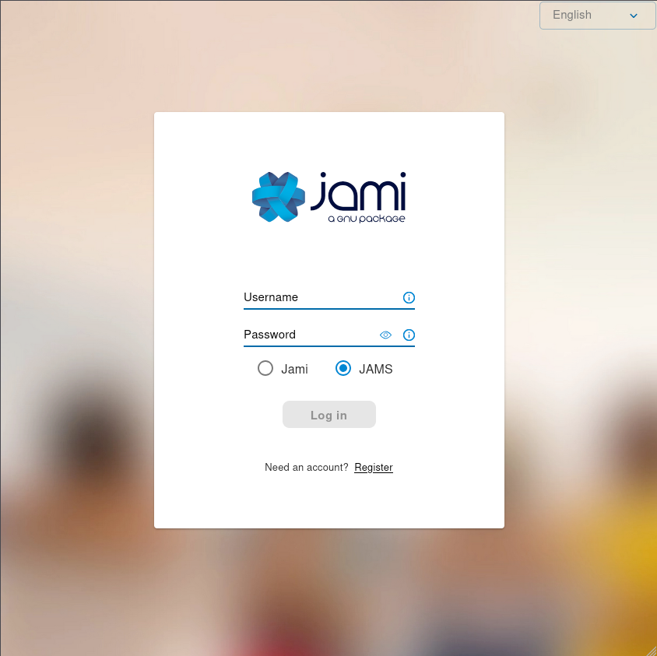
Select Log in.


Jami is the only software required for peer-to-peer (without a server) communication that respects the freedom and privacy of its users.
Jami is the simplest and easiest way to connect with people (and devices) with instant messaging, audio, and video calls over the Internet and LAN/WAN intranets.
Jami is a free/libre, end-to-end encrypted, and private communication platform.
Jami is open-source software that prioritizes user privacy.
Jami has a professional-looking design and is available for a wide range of platforms. Unlike the alternatives, Jami calls are directly between users, as it does not use servers to handle calls.
This gives the greatest privacy, as the distributed nature of Jami means all calls are only between participants.
One-to-one and group conversations with Jami are enhanced with instant messaging, audio and video calling, recording and sending audio and video messages, file transfers, screen sharing, and location sharing.
Jami can also function as a SIP client.
Multiple Jami extensions are available: Audio Filter, Auto Answer, Green Screen, Segmentation, Watermark, and Whisper Transcript.

Jami can be easily deployed in organizations with the JAMS (Jami Account Management Server), allowing users to connect with their corporate credentials or create local accounts. JAMS allows you to manage your own Jami community while taking advantage of Jami’s distributed network architecture.
Jami is available for GNU/Linux, Windows, macOS, iOS, Android, Android TV, and web browsers, making Jami an interoperable and cross-platform communication framework.
Manage multiple SIP accounts, Jami accounts, and JAMS accounts with the Jami client installed on one or multiple devices.
Jami is free, unlimited, private, advertising-free, compatible, fast, autonomous, and anonymous.
Jami: https://jami.net/
Extensions: https://jami.net/extensions/
JAMS: https://jami.biz/
Documentation: https://docs.jami.net/
Videos: https://docs.jami.net/videos/
Mastodon: https://mstdn.io/@Jami
Forum: https://forum.jami.net/
Contribute: https://jami.net/contribute/
Build IoT projects with Jami. Re-use the universal communications technology of Jami with its portable library on your system of choice.
Jami is published under the GPL license, version 3 or higher.
Copyright © Savoir-faire Linux Inc.

